LAB EXPERIMENT RECORD
SET 14: SURVEY RESULTS
Department | AIDS
Course Code / Course Name | DSA0601 / Data Handling and Visualization
Experiment | Data Visualization using R
Name | B. Pallavi
Register Number | 192424243
Date | 08 October 2026
Day | Thrusday

Aim
To visualize survey response data using a stacked bar chart, radar chart, and survey response table, and to build an interactive dashboard using R.
Dataset: Survey Results
Respondent | Question 1 | Question 2 | Question 3
1 | A | B | C
2 | B | A | D
3 | C | A | B

PROGRAM 1: Stacked Bar Chart of Question 1 Responses
Create a stacked bar chart to display the distribution of answers for Question 1. Label the chart elements.
R Code
# Dataset
respondent <- c(1, 2, 3)
question1 <- c("A", "B", "C")
# Count responses
response_count <- table(
factor(question1,
levels = c("A", "B", "C", "D"))
)
# Stacked Bar Chart
barplot(response_count,
main = "Distribution of Answers for Question 1",
xlab = "Question 1",
ylab = "Number of Responses",
col = c("skyblue",
"lightgreen",
"orange",
"pink"))
legend("topright",
legend = c("A", "B", "C", "D"),
fill = c("skyblue",
"lightgreen",
"orange",
"pink"))
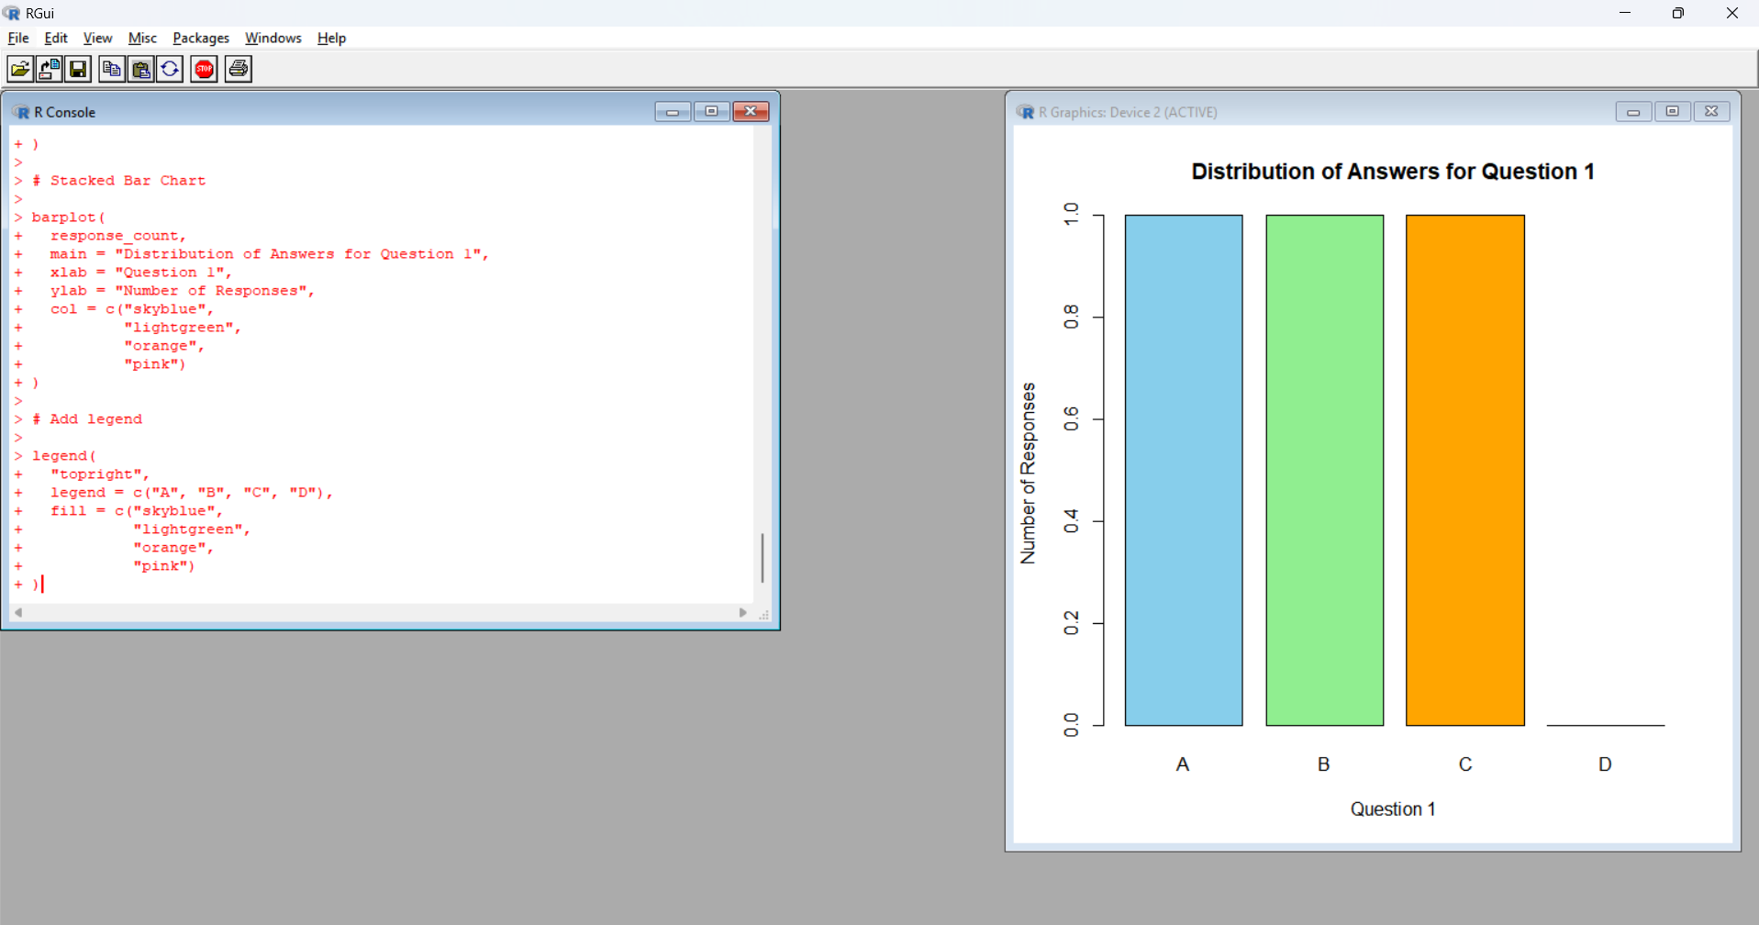
Output 1: Question 1 Response Distribution

The graph displays the distribution of answers A, B, C and D for Question 1.
Observation
The stacked bar chart shows that:
- Answer A has 1 response.
- Answer B has 1 response.
- Answer C has 1 response.
- Answer D has 0 responses.
Therefore, A, B and C have equal representation in Question 1.
PROGRAM 2: Radar Chart of Survey Responses
Generate a radar chart to visualize the overall pattern of responses across all three questions.
R Code
# Survey responses
question1 <- c("A", "B", "C")
question2 <- c("B", "A", "A")
question3 <- c("C", "D", "B")
# Count responses
responses <- rbind(
Q1 = table(factor(question1,
levels = c("A", "B", "C", "D"))),
Q2 = table(factor(question2,
levels = c("A", "B", "C", "D"))),
Q3 = table(factor(question3,
levels = c("A", "B", "C", "D")))
)
print(responses)
# Radar chart
categories <- c("A", "B", "C", "D")
angles <- seq(0, 2 * pi,
length.out = 5)
max_value <- max(responses)
plot(0, 0,
type = "n",
xlim = c(-max_value - 1,
max_value + 1),
ylim = c(-max_value - 1,
max_value + 1),
axes = FALSE,
xlab = "",
ylab = "",
main = "Radar Chart of Survey Responses")
# Draw radar axes
for(i in 1:4) {
lines(c(0,
max_value * cos(angles[i])),
c(0,
max_value * sin(angles[i])))
text(1.3 * max_value * cos(angles[i]),
1.3 * max_value * sin(angles[i]),
categories[i])
}
# Draw response patterns
for(i in 1:3) {
values <- c(as.numeric(responses[i,]),
as.numeric(responses[i,1]))
x <- values * cos(angles)
y <- values * sin(angles)
lines(x, y,
type = "o",
pch = 19)
}
legend("topright",
legend = c("Question 1",
"Question 2",
"Question 3"),
lty = 1,
pch = 19)
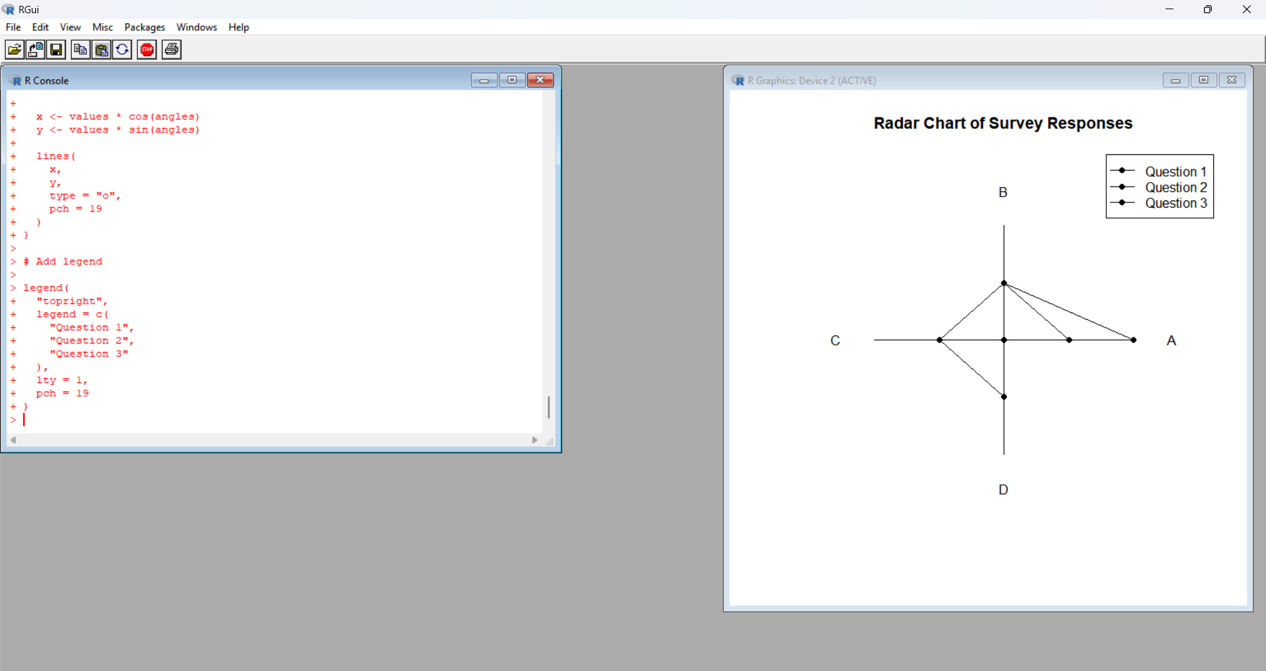
Output 2: Radar Chart of Survey Responses
The radar chart displays the response pattern for Questions 1, 2 and 3.
Observation
The radar chart shows that:
- Question 1 has one response each for A, B and C.
- Question 2 has two responses for A and one response for B.
- Question 3 has one response each for B, C and D.
- Question 2 has the highest frequency for answer A.
PROGRAM 3: Survey Response Table
Build a table to show the survey response data for each respondent. Label the table elements.
R Code
# Survey Response Data
survey_data <- data.frame(
Respondent = c(1, 2, 3),
Question_1 = c("A", "B", "C"),
Question_2 = c("B", "A", "A"),
Question_3 = c("C", "D", "B")
)
# Display Table
print(survey_data)
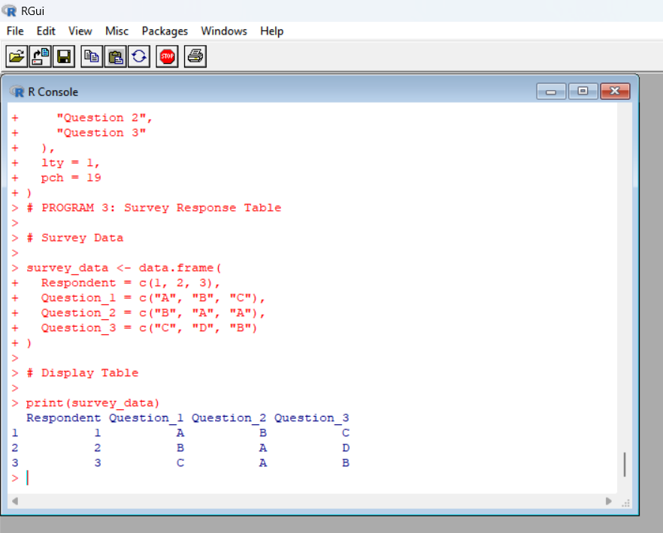
Output 3: Survey Response Table
Respondent Question_1 Question_2 Question_3
1 1 A B C
2 2 B A D
3 3 C A B
Observation
The table displays the complete survey response information for each respondent, including responses to all three questions.
PROGRAM 4: Interactive Survey Results Dashboard
Develop an interactive dashboard combining the stacked bar chart, radar chart, and the table for interactive exploration of survey responses.
Since you are doing the assessment in R 4.5.0, use R Shiny for the interactive dashboard.
Install Shiny
Run this only once:
install.packages("shiny")
R Code
library(shiny)
# Survey Data
survey_data <- data.frame(
Respondent = c(1, 2, 3),
Question_1 = c("A", "B", "C"),
Question_2 = c("B", "A", "A"),
Question_3 = c("C", "D", "B")
)
# User Interface
ui <- fluidPage{
titlePanel("Survey Results Analysis Dashboard"),
sidebarLayout(
sidebarPanel
selectInput(
"question",
"Select Question:",
choices = c(
"Question 1",
"Question 2",
"Question 3"
)
)
),
mainPanel{
plotOutput("bar_chart"),
plotOutput("radar_chart"),
tableOutput("survey_table")
)
)
)
# Server
server <- function(input, output) {
output$bar_chart <- renderPlot({
responses <- switch(
input$question
"Question 1" = survey_data$Question_1,
"Question 2" = survey_data$Question_2,
"Question 3" = survey_data$Question_3
)
counts <- table(
factor(responses,
levels = c("A", "B", "C", "D"))
)
barplot(
counts,
main = paste(
"Distribution of",
input$question
),
xlab = "Answer",
ylab = "Number of Responses",
col = c(
"skyblue",
"lightgreen",
"orange",
"pink"
)
)
})
output$radar_chart <- renderPlot({
responses <- rbind(
Q1 = table(factor(
survey_data$Question_1,
levels = c("A", "B", "C", "D")
)),
Q2 = table(factor(
survey_data$Question_2,
levels = c("A", "B", "C", "D")
)),
Q3 = table(factor(
survey_data$Question_3,
levels = c("A", "B", "C", "D")
))
)
barplot(
responses,
beside = FALSE,
main = "Overall Survey Response Pattern",
xlab = "Answer",
ylab = "Number of Responses",
col = c(
"skyblue",
"lightgreen",
"orange"
),
legend.text = TRUE
)
}}
output$survey_table <- renderTable({
survey_data
})
}
# Run Dashboard
shinyApp(
ui = ui,
server = server
)

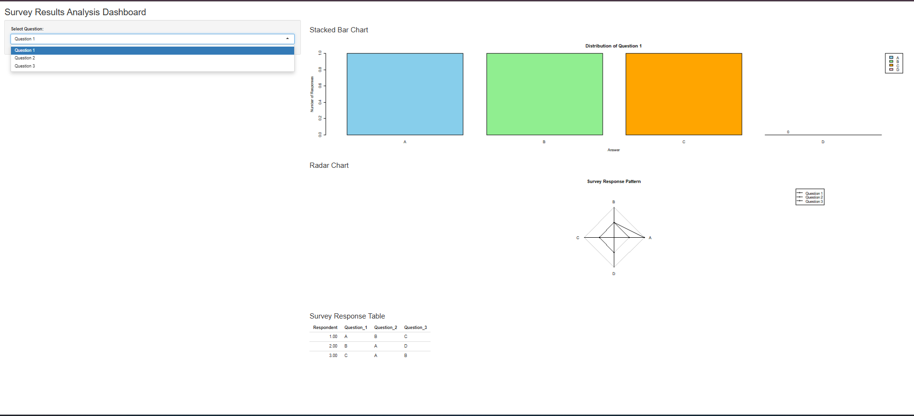
Output 4: Survey Results Analysis Dashboard
The dashboard combines the survey response visualization and survey response table into one interactive view.
Observation
The dashboard allows the user to select different questions and explore their response distributions along with the complete survey response table.
Procedure
- Create the survey response vectors in R.
- Use table() and barplot() to create the Question 1 stacked bar chart.
- Create response frequency data for all three questions.
- Use the response frequencies to create the radar chart.
- Create a data frame to display the survey response information.
- Install and load the Shiny package.
- Create the user interface for the dashboard.
- Create the Question 1 response visualization.
- Create the overall response visualization.
- Display the survey response table.
- Run the Shiny application to create the interactive dashboard.
Result
The survey response data was successfully visualized using a stacked bar chart, radar chart, and survey response table. An interactive R Shiny dashboard was also created to display and explore the survey responses.

